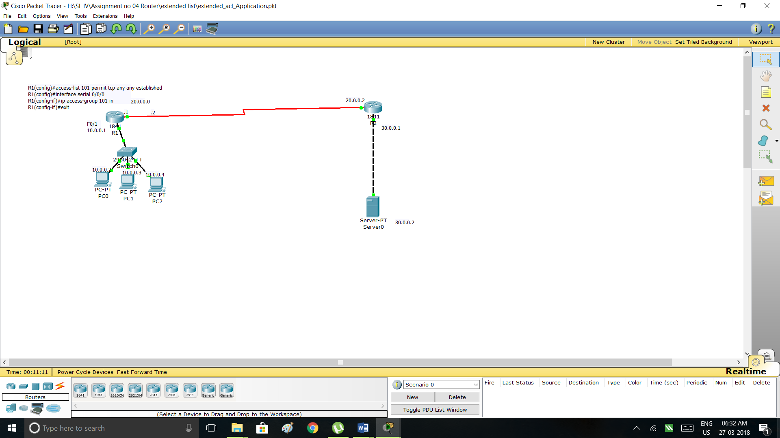

Router configuration

***R1(config)#access-list 101 permit tcp any established***

***R1(config)#interface serial 0/0/0***

***R1(config-if)#ip access-group 101 in***

***R1(config-if)#exit***

